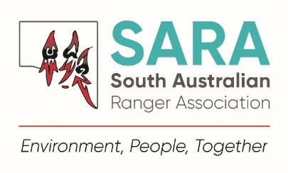

**Membership & Renewal Form**

Join us to support conservation locally and globally!

SARA undertakes activities to promote and enhance protected area management through education, training and knowledge sharing opportunities for environmental professionals in South Australia.

Become a member for access to:

* a diverse network of protected area management professionals

10% of all membership fees are donated to The Thin Green Line Foundation towards ranger projects around the world.

* social and development activities and events
* opportunities to attend interstate and international events and training
* staff exchange program support
* opportunities to help support The Thin Green Line Foundation charity work supporting rangers globally
* regular newsletters, social media group access and merchandise.

**Personal Details**

**New member**  **Membership renewal**

**Name: Employer/Agency:**

**Position: Region/Location:**

**Email: Mobile:**

**Postal address:**

**Do you identify as Aboriginal or Torres Strait Islander?**  **Yes**  **No**  **Prefer not to say**

**Open to employees of organisations engaged in the protection, preservation, interpretation and/or administration of a natural or cultural asset.**

**Alumni of an organisation such as that above, including retired staff.**

**Open to persons or associations actively engaged in the above activities or who support the objectives of SARA, including volunteers, students or other organisations.**

**Membership type**

**type type**

**Full Membership** $32.50

**SARA Alumni Membership** $15.00

**Supporting Membership** $15.00

**Payment Options**

Please select one of the following options:

Account name: South Australian Ranger Association

BSB: 805 050 Account: 90181314

**Direct Deposit** –for membership ending 30 June. Include your name in the reference and transfer to the following account:

Please return completed form by email to [sarangerassociation@outlook.com](mailto:sarangerassociation@outlook.com)

**Automatic Payroll Deduction (DEW staff only)** - to have your membership fees deducted from payroll ($1.25/fortnightly ongoing or until cancelled) please complete Direct Deduction Form.

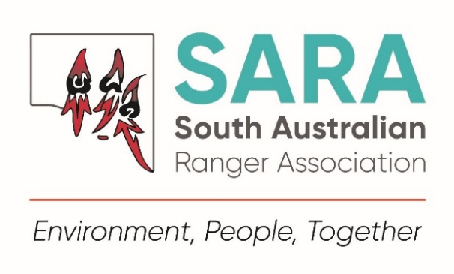

South Australian Ranger Association Membership Direct Deduction Form

This form can be used by employees of the Department for Environment and Water to deduct your South Australian Ranger Association membership fee fortnightly from your pay or to cancel your membership deductions.

I, ____________________________________________________, an employee of the Department for Environment and Water, employee number: __________________, wish to change the details of my payroll distribution by authorising the department’s payroll officer to process one of the below options:

Deduct a membership fee of one dollar and twenty five cents ($1.25) per fortnight commencing from the next pay period and deposit into the South Australian Ranger Association account.

Cancel the authority to deduct my membership fee of one dollar and twenty five cents ($1.25) per fortnight from my pay, commencing from the next pay period.

Signed ____________________________ Date _________________

Please return completed form by email to [sarangerassociation@outlook.com](mailto:sarangerassociation@outlook.com)

*For internal use:*

People’s Choice Credit Union

Account Name: South Australian Ranger Association

BSB 805 050

Account: 9018 1314

Shared Services Deduction Code: D983

*Secretary to update DL and forward form to Treasurer to update membership list and send form to Payroll.*