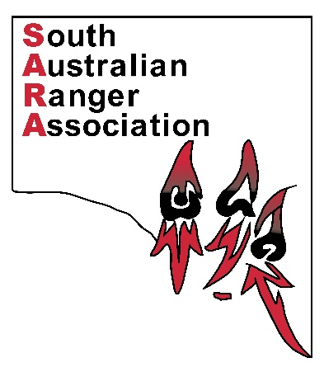

**South Australian Ranger Association Membership Deduction Form**

This form is used to deduct fees from your pay or to cancel your SARA membership.

I, ____________________________________________________, an employee of the Department of Environment, Water and Natural Resources, wish to change the details of my payroll distribution by authorising the departments payroll officer to process one of the following options below.

My employee number is ___________________________.

(please tick appropriate box)

* **Deduct membership fee of one dollar and twenty five cents ($1.25) per fortnight from my pay, commencing from the next pay period and deposit into the South Australian Ranger Association account.**
* **Cancel the authority to deduct my membership fee of one dollar and twenty five cents ($1.25) per fortnight from my pay, commencing from the next pay period.**

People’s Choice Credit Union

Account Name: South Australian Ranger Association

BSB: 805 050 / Account: 9018 1314

Signed ______________________________________________ Date _______________

Please return the completed form along with your membership application to:

Email: [DEWNR.SARangerAssociation@sa.gov.au](mailto:DEWNR.SARangerAssociation@sa.gov.au)

Mail: SARA Treasurer, Innes National Park, CMB Stenhouse Bay SA 5575.

**Treasurer to update membership list and forward form to Payroll.**